Medicines Optimisation:

**Background:** Medicines Optimisation is a critical aspect of healthcare management, especially in the United Kingdom. It involves understanding and distinguishing between three key categories of drugs: Branded, Generic, and Biosimilar. These distinctions are crucial for healthcare professionals and patients as they impact treatment decisions based on safety, quality, effectiveness, and cost.

**Branded Drugs:** These are innovator drugs initially developed and marketed by pharmaceutical companies under patent protection. During this period, only the original manufacturer can produce and sell the drug. Branded drugs are often more expensive due to the extensive research, development, and marketing expenses incurred.

**Generic Drugs:** Generic drugs become available once the patent for a branded drug expires. They contain the same active ingredients as branded drugs and have equivalent safety, efficacy, and quality. Generic drugs are typically more affordable because manufacturers do not need to bear the costs of research and development.

**Biosimilar Drugs:**  Biosimilars are biologic products highly similar to already approved biological medicines. They are developed after the patent protection for the original biological product ends. While not identical, they undergo rigorous regulatory scrutiny to ensure safety, efficacy, and quality. Biosimilars provide more affordable alternatives to costly biologic medications.

**The Approach**: The process of medicines optimisation involves several steps:

* Identifying drugs suitable for investigation.
* Researching and identifying BNF Codes or SNOMED Codes specific to the selected drugs.
* Collaborating with healthcare organizations and their Drugs and Therapeutics Committees to update formularies.
* Identifying and agreeing upon alternative drugs regarding safety, quality, effectiveness, and cost.
* Finalizing the formulary.
* Continuously monitoring prescribing and use.
* Providing feedback to prescribers regarding adherence to the formulary.
* Repeating the process as necessary, focusing on different disease areas.

**The Models**: Various tools and databases are used in medicines optimisation, including:

* An Access Database for tracking and managing drug-related information.
* A BNF-Bio-Similar-Generic-Drug-Cross-Ref-Database to cross-reference drugs and their codes.
* A Power BI Model (Meds-Optimisation) for data analysis and visualization.
* Monitoring tools for ongoing evaluation.

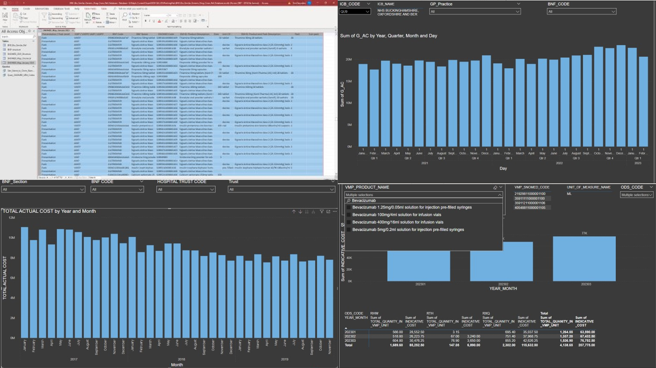**The Method:** The method involves systematically identifying BNF Codes and SNOMED Codes associated with specific drug names and populating a record table for subsequent investigation. This data is crucial for identifying, understanding, selecting, tracking, and managing drugs via the Formulary effectively. In summary, Medicines Optimisation is an essential component of healthcare management, combining data analysis and formulary management to enhance the quality of care, reduce costs, and improve patient outcomes in the UK healthcare system. From previous modelling exercises, we have found that ICB investment in Drugs Used in Diabetes range between £331/Patient to £391/Patient and that individual GP Practice investment varies between around £800/patient to around £150/Patient. From this exercise it was difficult to see any logical reasons for these investment decisions. Taking an average ICB with a DM Register of about 85,000 registered Diabetes patients then the difference in investment choice between lowest and highest is about £5,000,000 per year.